ASSIGNMENT 1

PART A
# 1) Print
echo "Students"
# 2) Remove spaces
echo -e "PES \bModern \bCollege \bOf \bEngineering"
# 3) Remove word behind \c
echo -e "Operating \cSystem"
# 4) Add new line
echo -e "Final \nSubmission"
# 5) Add tabs
echo -e "Operating \tSystem \tLab"
## ls
# 1) Long listing of files
ls -l

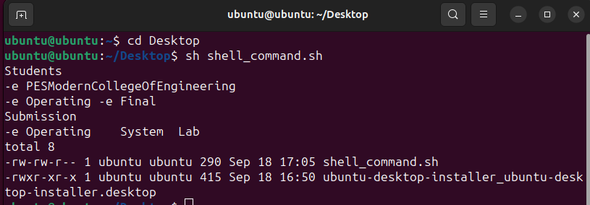
##read
# 1) Read value to variable and print
read name
echo "Hello $name!"

# 1) Create file
touch tempfile.txt

## cat
# 1) Copy the content of file source > destination
cat ./tempfile.txt > ../temp.txt

# 2) Show content of file
cat ./tempfile.txt

## test
# 1) Return 0 if name == Ash else return 1 (used to check the
previous command is successfully executed or not)
read name
test $name = Ash
echo $?

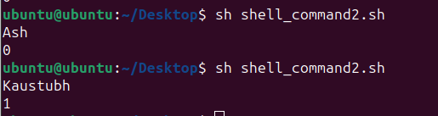

## Loops

# 1) For loop
for i in 1 2 3 4 5
do
echo "Value of i $i"
done

# 2) While loop

num=0
while [ "$num" -lt 5 ]
do
echo "Value of num $num"
num=`expr $num + 1`
done

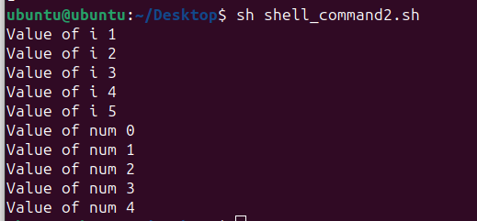

##Conditionals

# 1) If else block
read num
if [ `expr $num % 2` -eq 0 ]
then
echo "$num is even"
else
echo "$num is odd"
fi

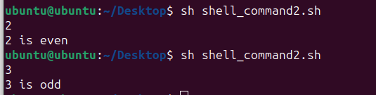

## grep

# 1) Return the line containing matching string (case insensitive)
grep -i 'Kaustubh Indulkar' ./tempfile.txt

# 2) Return the count/ occurance of given string
grep -c '27' ./tempfile.txt

# 3) Return the lines contains given string also adds line number
at begining
grep -n '27' ./tempfile.txt

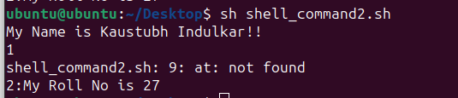

## sed

# 1) Replace 27 with 26
echo "Before Replacing Number"
cat ./tempfile.txt

echo "\nAfter Replacing Number"
sed 's/27/26/' ./tempfile.txt

